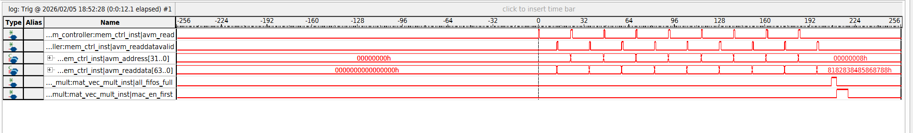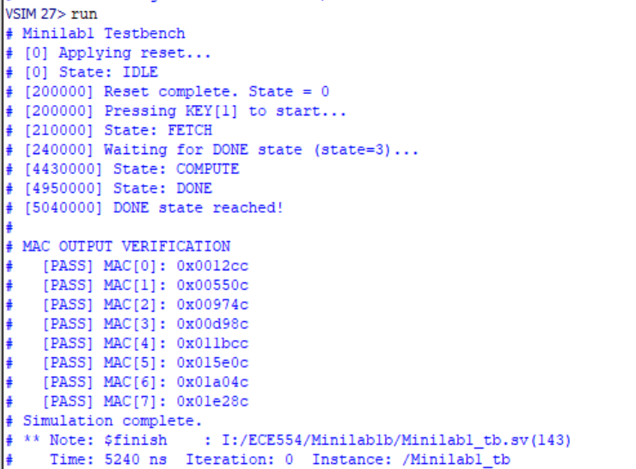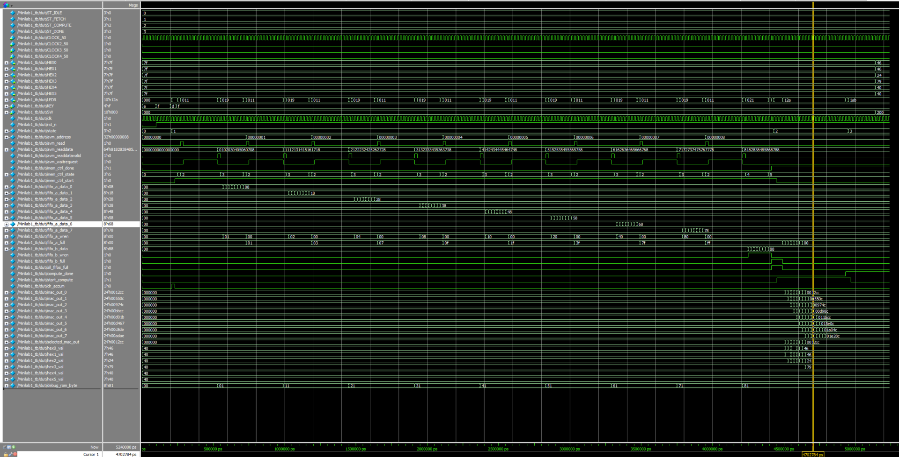

The design was tested in Questasim using text outputs that would show if each MAC had the correct value or not. To meet the timing constraint of 200MHz, we pipelined our mac and removed a state. On the board, our design used the LEDs to show the states of the different state machines and SW[2:0] was our different MAC indices. Flipping the switches would display the different MAC values. SW[9] was used to turn the display on and off. We ran signaltap on our board aswell. We followed the tutorial provided and used a couple of signals for our waveform. Avm_read would show that a read request was being sent. Readdatavalid would show that the read is successful. All_fifos_full would indicate that after 8 reads the fifos are all full. The biggest difficulty we faced was our display outputting all 0 values. This was happening due to a timing issue where all fifo values would arrive at the same clock cycle instead of being a cycle late to each other.

